***Task 4***

***Implementing a Multi-threaded Application to Fetch Data from a Database Statement: Implement a Java application that creates multiple threads, with each thread responsible for fetching data from a different table in a PostgreSQL database using JDBC. The application should concurrently retrieve and print the data from the tables. Requirements: ﻿﻿Create a PostgreSQL database with multiple tables (e.g., employees, departments, projects). ﻿﻿Implement a thread class that connects to the database and fetches data from a specified table. ﻿﻿Start multiple threads, each fetching data from a different table. ﻿﻿Use JDBC to connect to the PostgreSQL database and retrieve the data.***

***Solution:***

The provided code in Main.java and DatabaseFetcher.java implements a multi-threaded Java application to fetch data from different tables in a PostgreSQL database concurrently. The Main class initializes table names, a thread-safe ConcurrentHashMap for results, and a CountDownLatch to synchronize thread completion. For each table, it creates and starts a DatabaseFetcher thread. The DatabaseFetcher class extends Thread, connects to the PostgreSQL database via JDBC, retrieves and formats data from the specified table, and stores the results in the ConcurrentHashMap. After all threads complete, the main thread prints the results, ensuring efficient and thread-safe data retrieval.

***Output:***

**Multiple threads, each fetching data from different tables and printing the data**

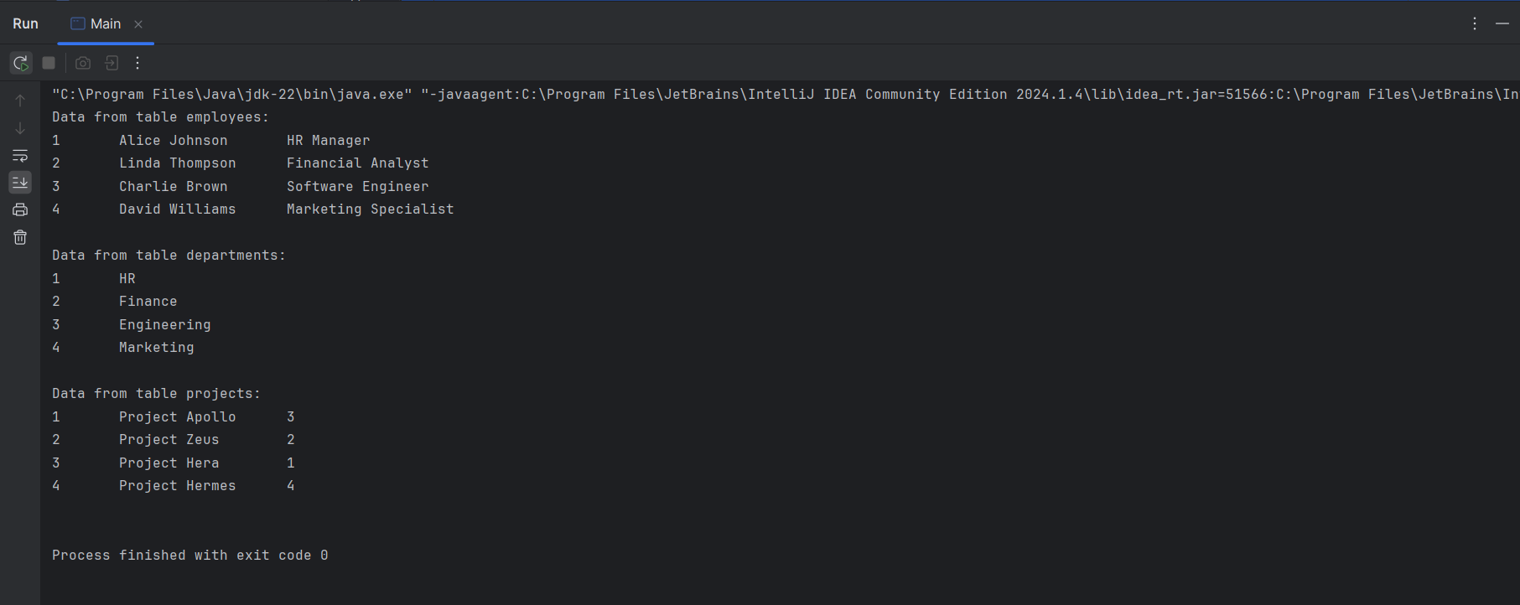

***Employees table:***

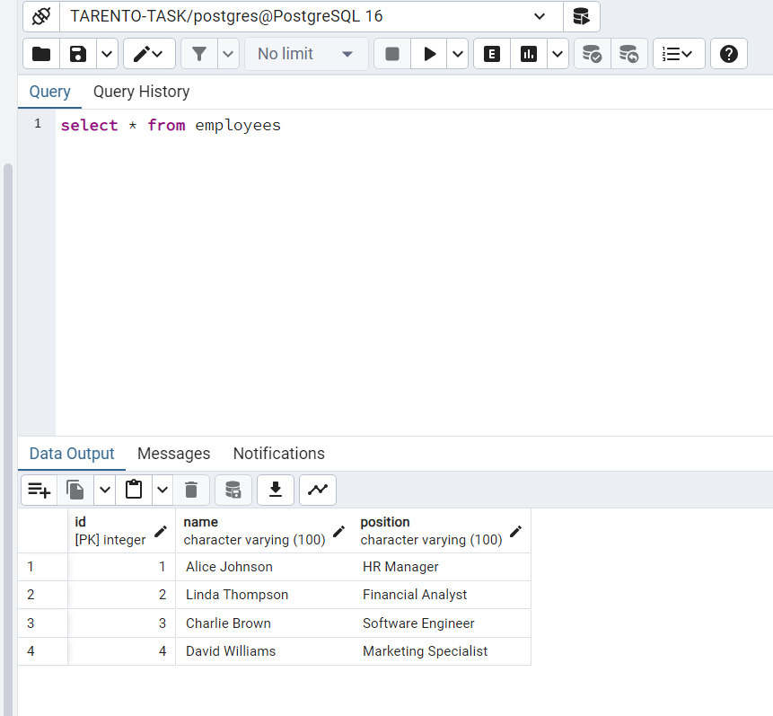

***Departments table:***

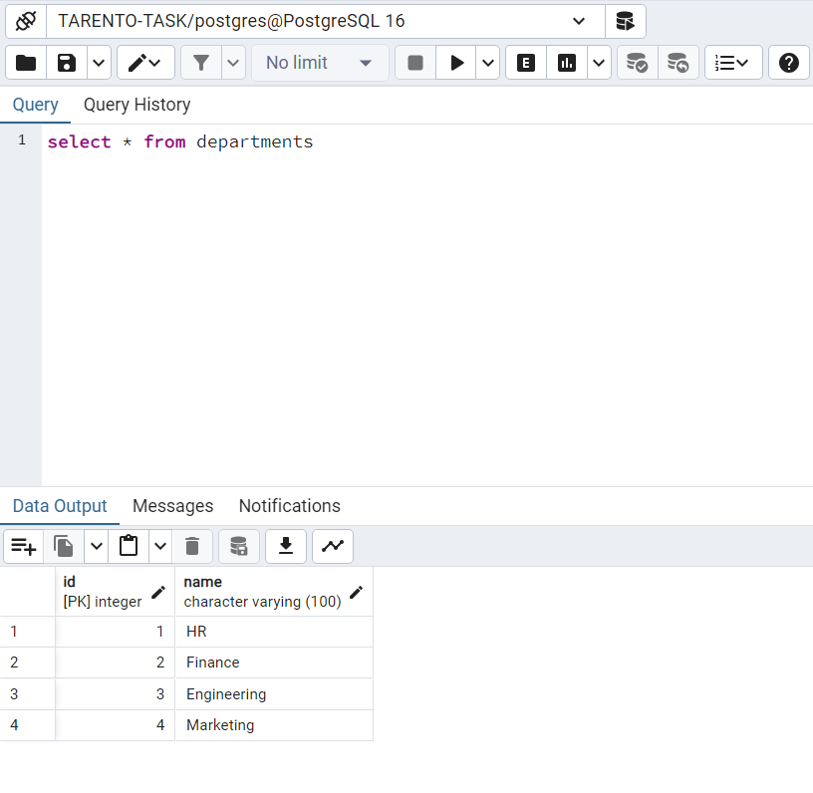

***Projects table:***

